

18DCO301J - DATA X – APPLIED DATA SCIENCE WITH VENTURE APPLICATION

Optimum Store

Submitted by Eeshan Dutta – RA1911003010256

**Team Members** **(B1T7)**

|  |  |
| --- | --- |
| **Register Number** | **Name** |
| RA1911003010219 | Aditi Rastogi |
| RA1911003010541 | Arhan Choudhury |
| RA1911003010513 | Hardik Garg |
| RA1911003010283 | Rohan Kumar |
| RA1911003010259 | Tanisha Bisht |
| RA1911003010256 | Eeshan Dutta |

1. **Introduction**

* Optimum Store makes inventory management as easy as it can ever get. Shopkeepers know the pain of keeping logs of what is sold, what is brought from the manufacturer, and of course how many items to buy to get maximum profits. Optimum store alerts you whenever your stock goes below a certain amount, so that you don’t lose a potential customer. It tells you how much to buy so that you don’t buy less or more, optimum is the term we prefer. It also gives you the feature to periodically look into your stock and item logs and purchase accordingly thereby maximising the profit of the shopkeeper.

**1.1 Need of the Project**

* Our product is needed by all kinds of retail shop owners who wants to manage their inventory in an easier and effortless way and want a system to maximise their profits learning from the past sales of that very shop.

**1.2 Approach**

* We are using **Monte Carlo Ray Forecasting** machine learning algorithm on the datasets to find the optimum amount of stock of the product to be purchased at the right time, we are using react as our front-end library.

**1.3 Benefit**

* Our product makes it easier for the shop owners to manage their inventory storage to maximize their profits.

**1.4 Competition**

* Our project is unique, there is no big player in the market who does what we do. But still we need to help small shop owners to compete with the big retail chains who are already using machine learning algorithms to understand trends and maximize their sales.

1. **Customer Validation**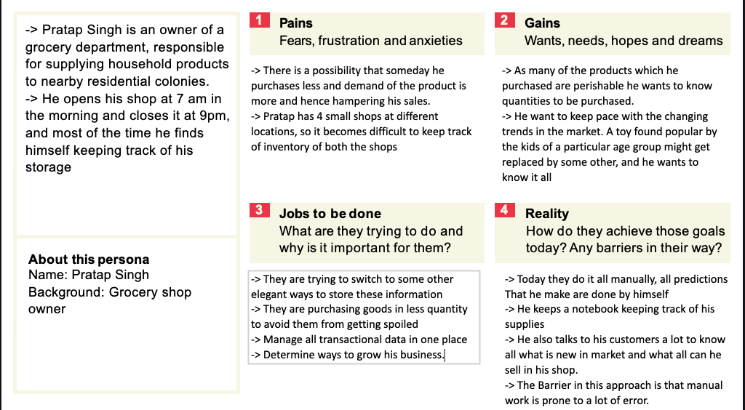

1. **Project Description**

* “Optimum Store” is a website for the retailers. Buying products to sell can be tricky, as it is all prediction, what people want, and how much will they need. Our website will do this work for the retail shop owners.
* We will be using product name, category, date, quantity along with the fact that day was a holiday or not as a factor to predict how much the retail shop owner will sell, so based on that information they can purchase the product from the manufacturer.
* Along with this we will be providing inventory management system for the user so that they can keep a record of what all items they currently have and for which item they have to place order.
* Our website is allowing the shop owner to manage their inventory smartly and achieving maximum profit.

**3.1 Illustrate the UI/ Input, output**

* Input :- i) Product Name ii) Category iii) Date iv) Quantity
* Output :- Single value or a range of value telling the quantity of product to be purchased

**3.2 Technical Components of the project**

1. User Interface
2. Use of Machine Learning and Neural Networks
3. Datasets (transaction log of past years of the shop)
4. Inventory Management

**3.3 Sample System Architecture**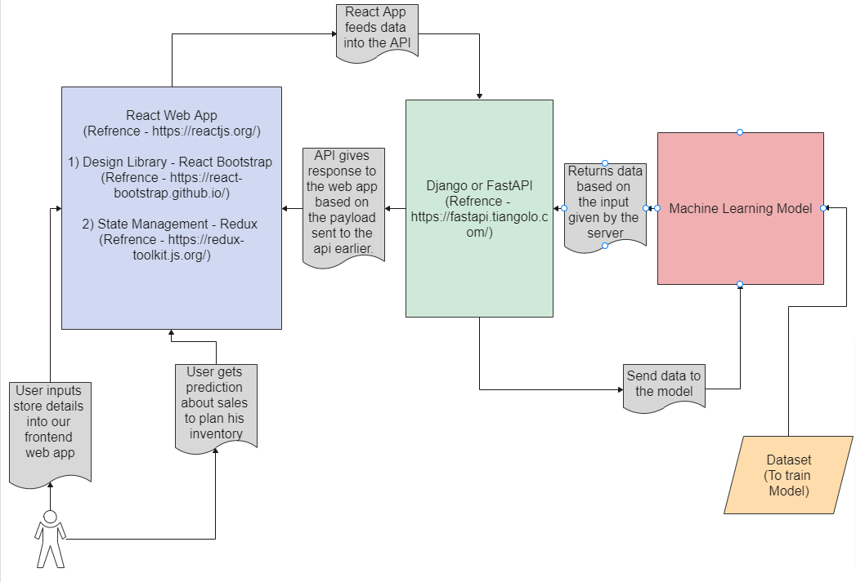

1. **Business Plan**

**4.1 Key activities**

🡪 ***Platform Development and maintenance*** : The website or the platform for our clients will be developed and maintained with respect to the changing market

🡪***Marketing Ads*** : The marketing of the Optimum store will be done through Online advertisements so that it reaches more audience

🡪***Finding Retailers*** : In order for optimum store to be in the market retailers will be contacted

**4.2 Key Resources**

🡪***Retail Network*** : The key to the success of Optimum store is the Retail network

🡪***Tech Platforms*** : In order to roll out Optimum store online tech platforms will be used.

🡪 ***Talented Employees*** : In order for optimum store to work a team of talented employees will be hired

🡪 ***Brand*** : The Brand is what that makes Optimum store the best in the market

**4.3 Key Partners**

🡪***Investors*** : The investors will be a key part in funding of the project

🡪***Retail Chain / Individual shop owners*** : The retail chains are what that makes the optimum store working

**4.4 Value Propositions**

🡪***Low cost luxury*** : This would be considered as a low cost luxury for retail chains and shop owners

🡪 ***Increase profits*** : This will increase profits and decrease loss

🡪 ***Anytime, anywhere*** : Can be used anytime and anywhere

🡪***Prevent wastage*** : It prevents wastage of perishable items resulting in increased profit

🡪 ***Various level of services*** : we provide services at various levels.

**4.5 Cost Structure**

🡪 ***Tech platform costs*** : Covers the cost of the online maintenance of website and server

🡪***Marketing and ads*** : Covers the cost used for marketing Optimum Store

🡪 ***Employee payroll*** : Covers the cost of the employees

**4.6 Revenue Streams**

🡪 ***Monthly charges of services*** : The income generated by the retail chains

**4.7 Customer Segment**

🡪 ***Retail store owners*** : Provided for the retail store owners

🡪 ***Manufacturers*** : will be provided for the manufacturers

**4.8 Customer Relationship**

🡪 ***Personalised Touch*** : Optimum store can be designed specifically for Clients

**4.9 Channels**

🡪 ***Website*** : Optimum store will be operated through an online channel

1. **Financial Plan**

**5.1 Growth Strategy**

We plan to launch our product with a price as low as Rs. 200/month for the customers joining us early. We estimate to have 500 customers by the end of the first year of our business. Since our product can be used by shop owners selling different products in different quantities we can assume high traction.

In the following years we can increase our prices to Rs. 450/month, with some increase in number of customers. The Addition to our customers will increase with sudden spikes when we will enter new markets.

**5.2 Traction**

We will start our marketing and advertisement via local shop owners, and as the prices are very less we can expect some kind of response from the shop keepers. As we will get more happy customers their testaments and mouth publicity to other potential clients will become our major source of traction. We will also consider giving ads on google etc.

**5.3 Financials**

Our income will be strictly coming from the monthly charges the customers are going to pay for our services.

For the first year 500 X 200 = 100000

For the second year 750 X 450 = 337000

And so on for subsequent years

When it comes to expenditure, we will need to host our certificate, with an SSL certificate. And as out database will increase we will need to scale our database accordingly. Apart from that salary of the people who will be working with us will be another big expenditure to be considered.

1. **Conclusion**

Thus, to conclude , Optimum store is a easy , efficient and easy-to-use and reliable inventory management system that gives the shop keepers a clear and meaningful insight of the items in stock and help them to minimize the wastage of items that are expired or those that may expire soon. It basically helps the shop keepers know the sales of items by easy to understand visualizations and also predict weather an item will sell within the perishable duration.